- Add two product categories of your choice
Query:

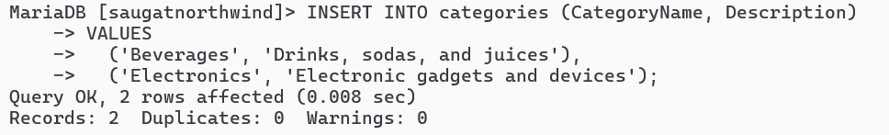
- Add 3 new suppliers in suppliers table
Query:

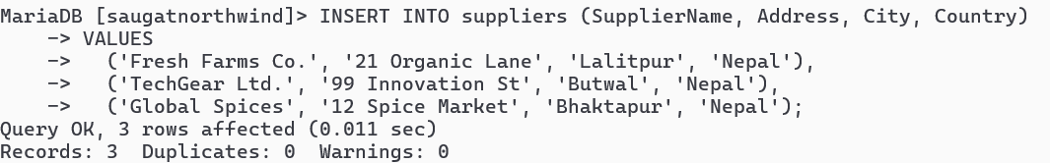
- Add 5 new customers in customers table
Query:

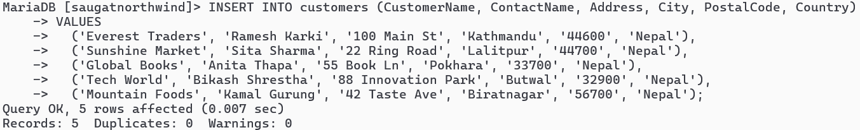
- Add 4 products in product table
Query:

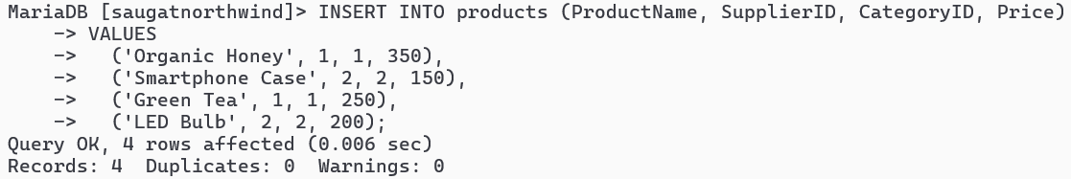
- Add 3 new employees.
Query:

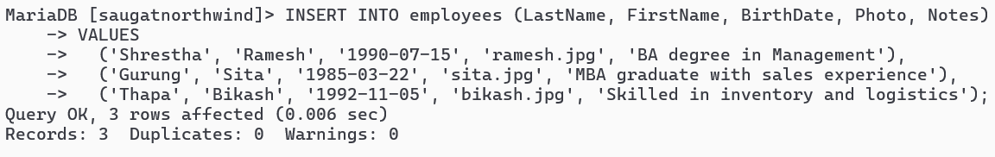
- Update all customers from Mexico to Vietnam
Query:

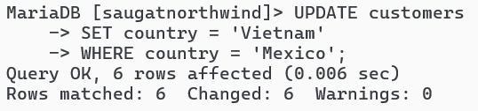
- Update customers table changing name of Paris City to Delhi
Query:

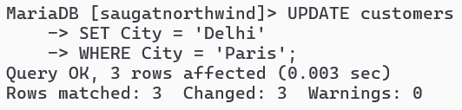
- Update all USA customer to Indian customers
Query:

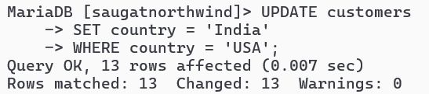
- Convert all Brazilian customer to Combodian Customers
Query:

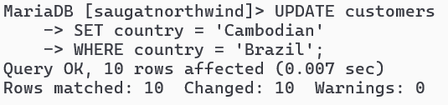

- Convert all customers of Madrid to Kathmandu customers also change name of country
Query:

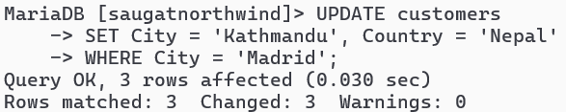
- Convert customers from G7 Countires to SARCC Countries
Query:

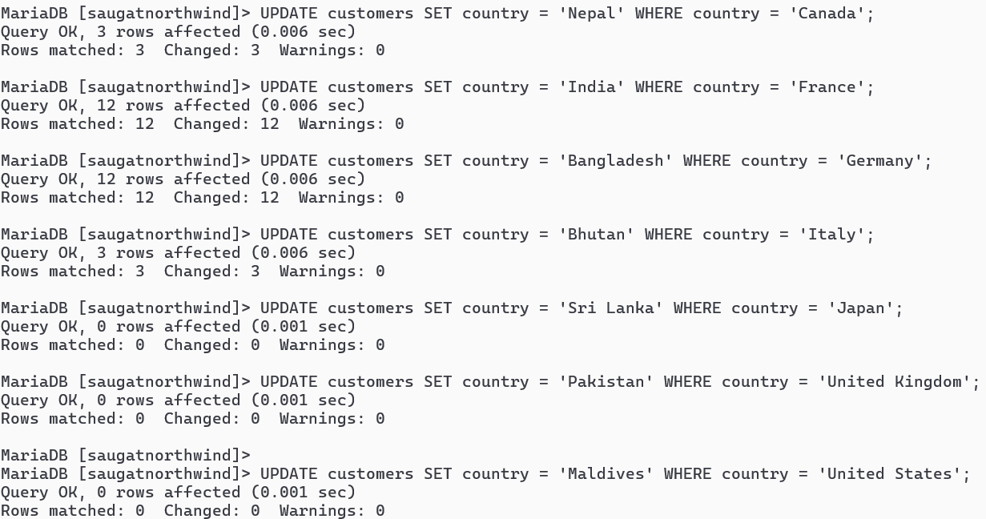
- DELETE all records from orders and orderdetails
Query:

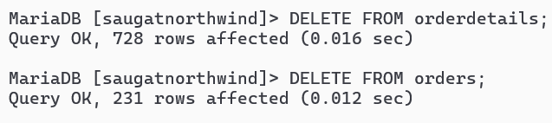
- DELETE all from customers who have PostalCode containing 31
Query:

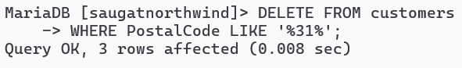

- DELETE all from customers having PostalCode containing 00 and from Rome or Paris.
Query:

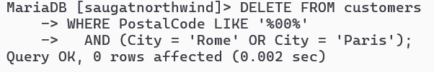
- DELETE all from customers who are not from Salzburg
Query:

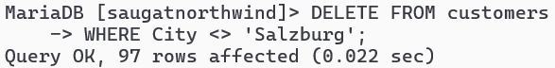
- DELETE all employees who are born on July
Query:

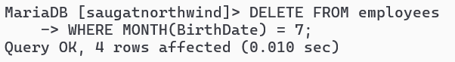

- DELETE all employees who are born on August
Query:

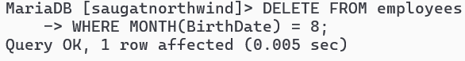
- Find name and count of suppliers from different countries.
Query:

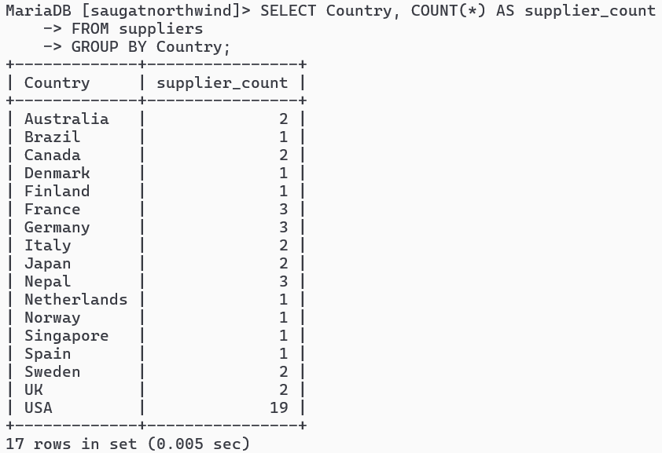
- Find name and count of customers from different cities.
Query:

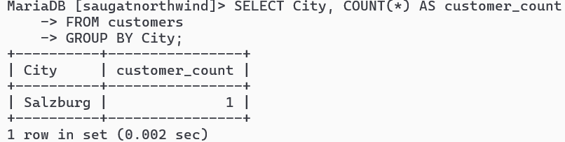

- Find number of orders made by employee along with employeeID
Query:

